Minutes of the Annual General Meeting - 2020

Held on ZOOM @ 6:30pm
November 27, 2020
6:30 to 7:00 pm – registration
7:00 to 7:30 pm – meeting
Attendees (see the excel table attached)

1. Call to order, welcome, introductions, registration.
The meeting was called to order at 6:30 pm. Registration: Daniela Dobreva and Vania Alexieva reported: the society currently has 135 members, from which altogether 56 members - present or represented by proxies. The attendee and the list of the people represented by proxy are below as well as here.
Attendees in person:
Attendees by proxy:

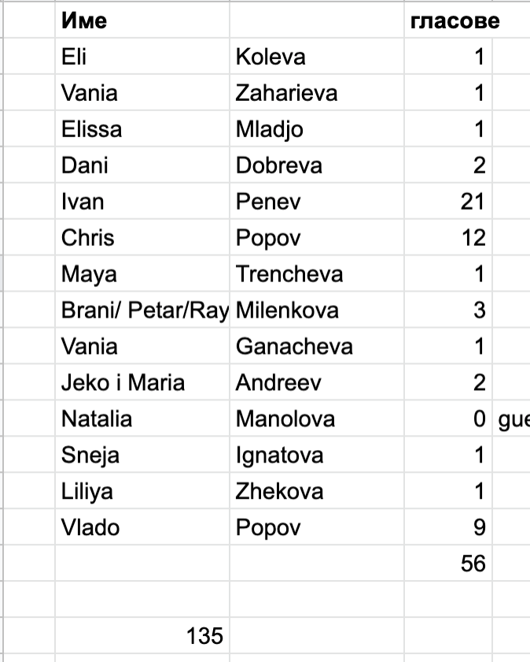
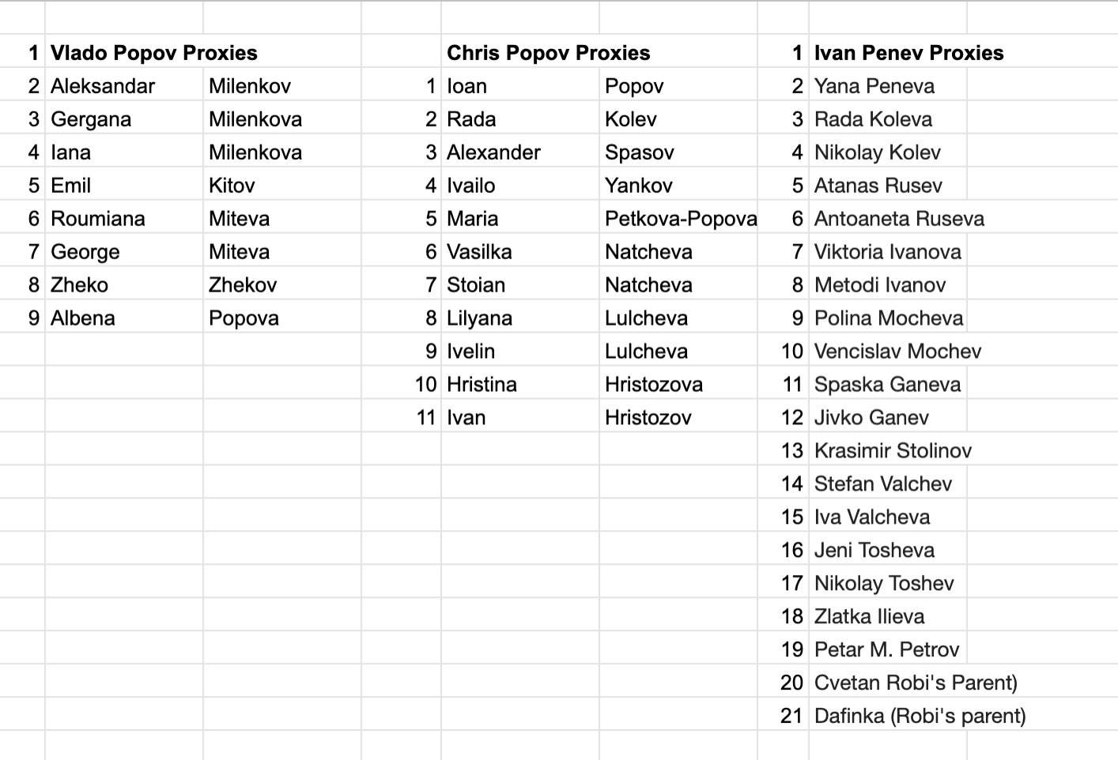

2.Election of Chair.
Vania A. suggested that Ivan Penev be the Chair. Daniela D seconded. All in favor. Ivan Penev was elected as a Chairman.

3. Activity report of the Bulgarian-Canadian Society for the previous year.
Vladimir Popov - the President of the Society, presented the annual report. It was reported that the reported year October 2018 – December 2019 was a successful one. The report is in Bulgarian and it is here.

4. Financial report. Vania A. presented the financial report. Vania A. had worked on the report together with Borislava Ilieva. The Profit/Loss and the Balance Sheet as of September 2019 is here.

5. Election of New Board of Directors and President.
Elissa Mladjo resigned as a Board member. Three new Bord members were introduces: Hristo Popov, Snejana Ignatova and Lili Zhekova. All board members were voted in favor and were welcomed.
Board of Directors election

7. Closing the meeting and thank you remarks.
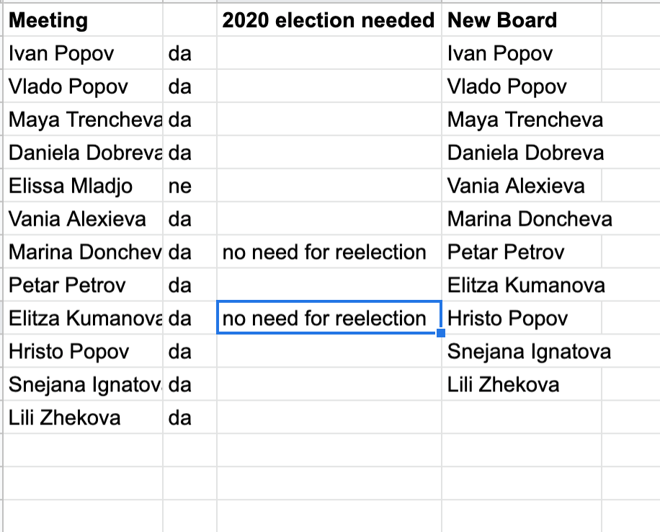
The recording of the meeting is here:

The meeting was adjourned at 7:55 pm.

